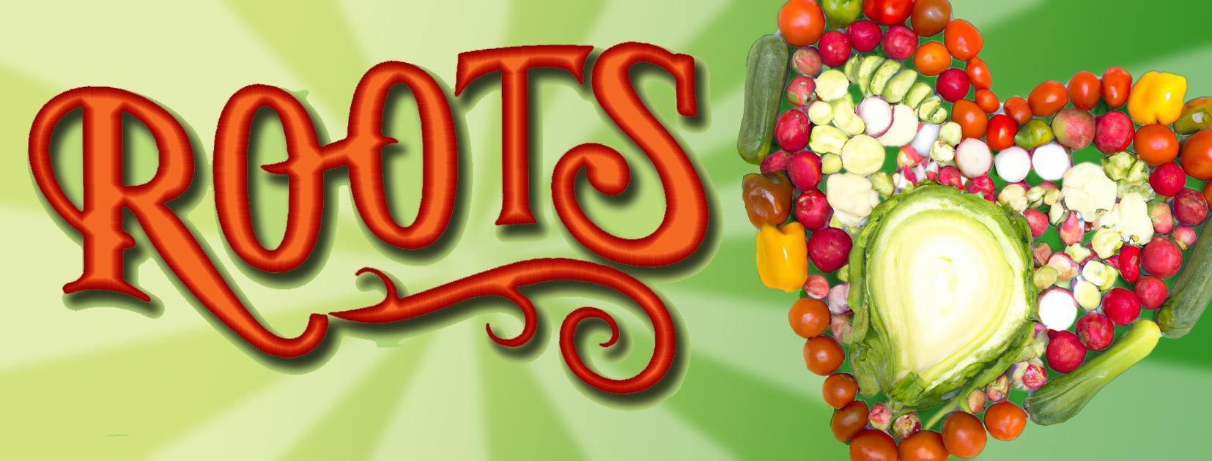

**FASHION SHOW GUIDELINES**

Come and show that op-shop type second hand clothing is the way to do.

We’ll specially be delighted if we could have a sample of the following “best off” during the party:

**Most Frivolous style. Best bang for buck. Best party outfit. Most Bizarre. Most professional attire. Most outrageous. Best 70’s style. Best 60’s style. Best 50’s style. Best dance outfit. Most likely to turn heads at a party. Most flashy ensemble. Sexiest outfit man. Sexiest outfit woman. Retro chic. Retro work-style, Retro party-style, Retro children’s style.**

Help show us that dressing retro can be colourful, stylish, economic, fun to wear and functional!